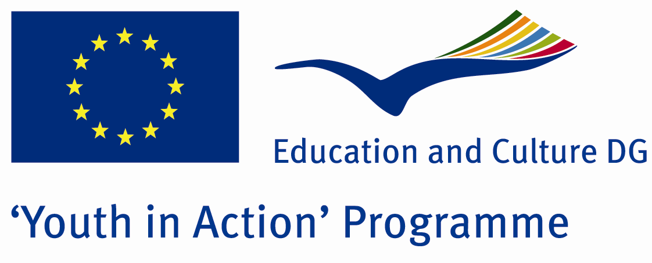

The Future of Children



ACTION 4.3 – Training And Networking

30 December 2011-06 January 2012

Balıkesir/TURKEY

Please contact directly to;

adventurerpeacepigeons@gmail.com

Project Summary;
This Project is about youngsters who are arrested because of stealing something, drugs, disturbing people and like that. You know youngsters are our future. One day they will dominate this world… And thousands people are living in the street. There is no education, no food, no home, no family… We want to attract attention for these people. Everything doesn’t mean fun or holiday or car or Money… Sometimes, you must save your environment, your people or world… For example Edison discovered electric and now you are using it… Or computer or other things… I mean that if you live in this world, you must add something. Start with youngsters who are living in street. Let’s do something for them… Maybe a small present, maybe a smiling face… Give your family love for them… If you want to join us, please send your application form…

Project Title; The Future of Children

Date and Venue; 30 December 2011-06th January 2012, Balıkesir/TURKEY

Target Group; Non profit/non governmental organization, Public body, Body active at European level in the field of youth (ENGO), Informal group of young people, e.t.c…

Participants; 5 people from each country (18 - 25). Totally 8 countries.

Conditions; Accommodation, board and programme costs will be financed through European Commission Youth in Action Programme (Action 4.3). Travel costs will be reimbursed in 70% (APEX Tarrifs). Organizations from all 27 EU member countries plus Liechtenstein , Norway and Iceland are eligible to take part.

Working language: English

Organizer; Discovery And Adventure Group

How to apply: If you are interested, please send your Part III forms to
by e-mail please (in word file). Scan Part3 format is enough for application.(Fulfilled Part III which you can find in the attachment, of course signed and stamped) ..

Next step 2;
Original send via regular post to this address please:
Ertan DERİN
Fevzi Çakmak Mahallesi Tuncer Sokak No:6 PENDİK/İSTANBUL/TÜRKİYE
e-mail : adventurerpeacepigeons@gmail.com
Mobile : 0090 542 393 93 90

If you have any questions you may contact with: adventurerpeacepigeons@gmail.com
Deadline: 15th May 2011

For Further information:
Contact Person
Ertan DERİN
Fevzi Çakmak Mahallesi Tuncer Sokak No:6 PENDİK/İSTANBUL/TÜRKİYE
e-mail : adventurerpeacepigeons@gmail.com
Mobile : 0090 542 393 93 90

